LABASSIGNMENT3.5

ǪUESTION-1:Zero-ShotPrompting(LeapYearCheck)
Writeazero-shotprompttogenerateaPythonfunctionthatchecks whetheragivenyearis aleapyear.
PROMPT:
WriteaPythonfunctiontocheckifayearisaleapyear CODE:
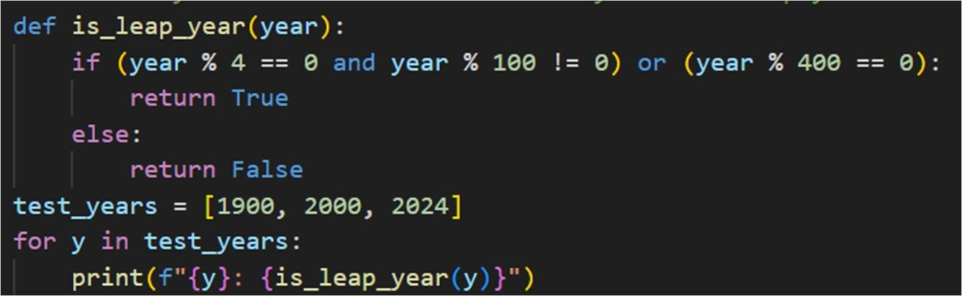
OUTPUT:

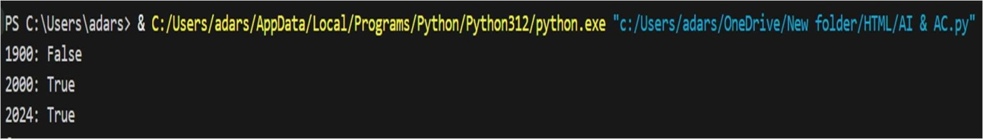
ǪUESTION2:One-ShotPrompting(GCDofTwoNumbers)
Writea one-shotprompt withone example togenerate aPython functionthatfindstheGreatestCommonDivisor(GCD)oftwonumbers.
PROMPT:WriteaPythonfunctiontocalculatethegreatestcommondivisor(GCD)of twonumbers

CODE:

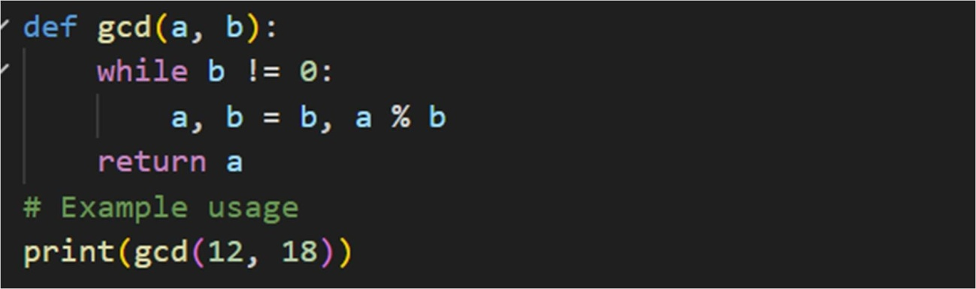
OUTPUT:
ǪUESTION3:
Few-ShotPrompting(LCMCalculation)
Writeafew-shotpromptwithmultipleexamplestogenerateaPython functionthatcomputestheLeastCommonMultiple(LCM)
PROMPT:
#WriteaPythonfunctiontocalculatetheleastcommonmultiple(LCM)oftwonumbers CODE:
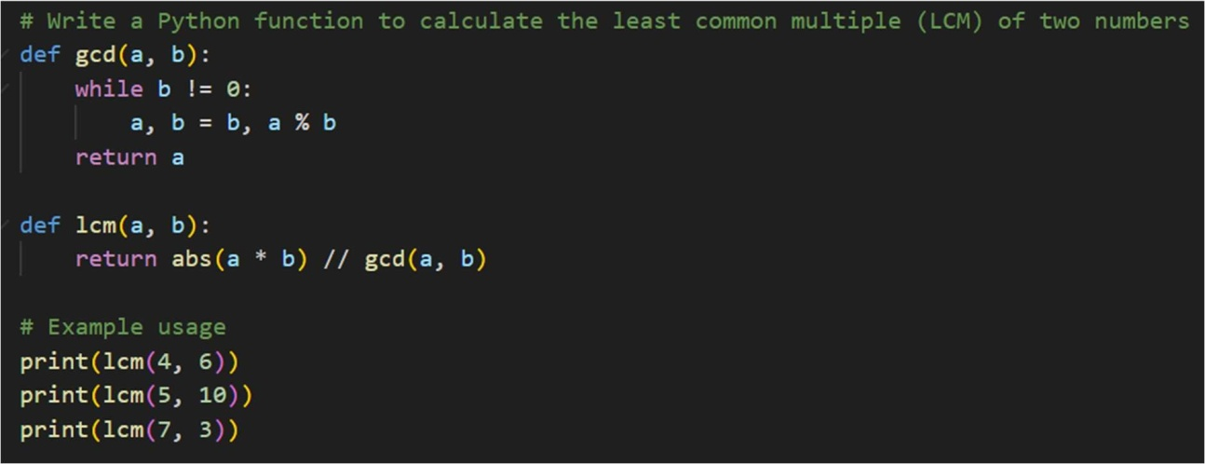
OUTPUT:
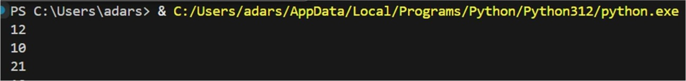

ǪUESTION4:
Zero-ShotPrompting(BinarytoDecimalConversion)
Writeazero-shotprompttogenerateaPythonfunctionthatconvertsa binary number to decimal.
PROMPT:
WriteaPythonfunctionthatconvertsabinarynumber(stringinput)intoitsdecimal equivalent.
CODE:
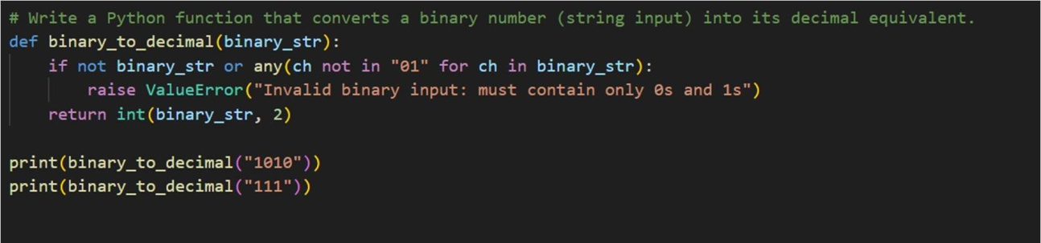
OUTPUT:

ǪUESTION5:
One-ShotPrompting(DecimaltoBinaryConversion)
Writeaone-shotpromptwithanexampletogenerateaPythonfunction that converts a decimal number to binary.
PROMPT:
Writeafunctionthatconvertsadecimalintegerintoitsbinaryrepresentationasa string.
CODE:

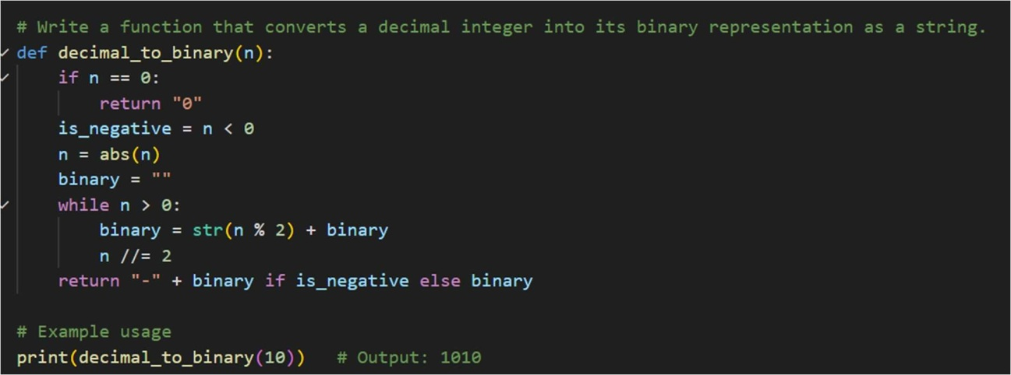
OUTPUT:
ǪUESTION6:
Few-ShotPrompting(HarshadNumberCheck)
Writeafew-shotprompttogenerateaPythonfunctionthatchecks whether a number is a Harshad (Niven) number
PROMPT:
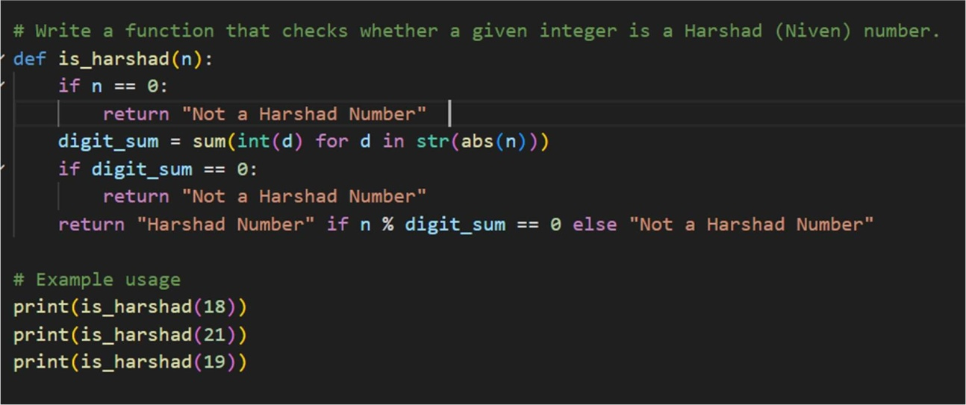
#WriteafunctionthatcheckswhetheragivenintegerisaHarshad(Niven)number. CODE:

OUTPUT:

